Growth Factor Double Team Promotes Breast Cancer

February 9, 2015 | Cancer Stem Cells
Cancer stem cells (CSCs) are thought to represent the origin of tumor development, but our knowledge about the basic mechanisms behind their self-renewal and differentiation remain relatively unknown. Breast cancer cells express and secrete nerve growth factor (NGF) [1] and its precursor protein, with its own specific mode of action, proNGF [2], and so may be important components of the breast CSC niche. Now, in a study in Stem Cells, researchers from the laboratory of Xuefen Le Bourhis (Inserm, Université Lille, France) have found that NGF and proNGF promote symmetric divisions of quiescent CSCs and epithelial to mesenchymal transition (EMT), and thereby promoting breast cancer tumorigenesis [3].
Using anchorage‐independent conditions in a serum free defined medium, the researchers found that NGF and proNGF enhanced tumorsphere formation from various breast cancer cell lines. Sphere‐forming capacity and monolayer colony formation increased in successive second and third sphere generations of cells from the initial sphere, suggesting an increase in CSC number and clonogenic potential. Using the aldehyde dehydrogenase‐1 (ALDH1) activity assay, the group confirmed that both NGF and proNGF boosted the numbers of CSCs in sphere culture, but not in monolayer cultures. NGF and proNGF also induced the number of quiescent CSCs, a mechanism which protects against loss of self-renewal capacities and promotes the maintenance of the CSC pool, mainly through the promotion of asymmetric cell divisions which amplify the stem cell pool.
The common neurotrophins receptor p75NTR marks several adult stem cells [4], and regulates breast cancer cell survival and drug resistance [5], and so the authors studied this receptor as a possible mediator of NGF and proNGF effects. NGF and proNGF are thought to interact with p75NTR or p75NTR-containing complexes, and in this study, the researchers observed a high level of p75NTR in CSCs. Furthermore, they observed the abolishment of NGF- and proNGF-mediated effects after siRNA-mediated silencing of p75NTR. p75NTR may therefore link NGF and proNGF to the regulation of CSC function, a novel mechanistic finding.
Moving to in vivo analysis, the group assessed tumors derived from NGF or proNGF pre‐treated breast cancer cells derived from the first generation of tumorspheres. Interestingly, pretreated cells generated tumors which developed quicker, grew faster, and metastasized more than untreated cells (See figure). Analysis of metastasized cells as a xenograft-derived culture found that NGF treated cells formed bigger tumorspheres and were highly enriched for putative breast CSCs (CD44high/CD24low phenotype [6]), as compared to levels observed in initial monolayer cultures before injection into mice. Furthermore, NGF treated cells also displayed multiple characteristics of epithelial to mesenchymal transition (EMT), a program that promotes the self‐renewal capacity of disseminating cancer cells [7]. Such changes included reduced cell‐to‐cell interactions, a spindle‐like shape, increased migratory capacity, loss of epithelial markers (keratin 18, keratin 19 and E‐cadherin), and the expression of multiple EMT‐associated genes. In comparison, proNGF mediated a similar although lesser effect and this may be due to a reduction in protein abundance during processing to NGF which then mediates an effect.
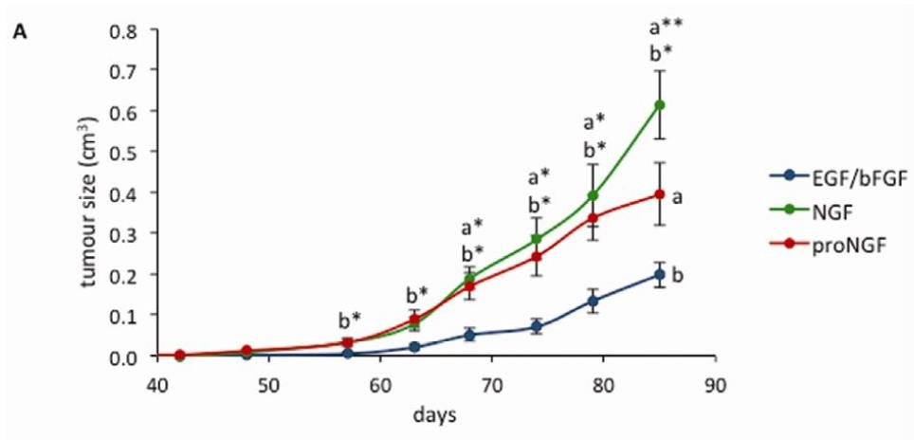
The authors provide the first evidence that suggests a critical role for NGF/p75NTR/proNGF in the regulation of breast CSC, and that NGF primes molecular changes that lead to EMT. This provides multiple targets for the generation of an effective anti-tumor therapy targeted at CSCs. The authors propose a further examination of the effects of the ratio of NGF and proNGF during tumorigenesis which may shed light on how NGF/p75NTR/proNGF regulates breast cancer development.
References
- Adriaenssens E, Vanhecke E, Saule P, et al. Nerve growth factor is a potential therapeutic target in breast cancer. Cancer research 2008;68:346-351.
- Demont Y, Corbet C, Page A, et al. Pro-nerve growth factor induces autocrine stimulation of breast cancer cell invasion through tropomyosin-related kinase A (TrkA) and sortilin protein. The Journal of biological chemistry 2012;287:1923-1931.
- Wang Y and Jiang T Understanding high grade glioma: molecular mechanism, therapy and comprehensive management. Cancer Lett 2013;331:139-146.
- Tomellini E, Lagadec C, Polakowska R, et al. Role of p75 neurotrophin receptor in stem cell biology: more than just a marker. Cellular and molecular life sciences : CMLS 2014;71:2467-2481.
- Verbeke S, Tomellini E, Dhamani F, et al. Extracellular cleavage of the p75 neurotrophin receptor is implicated in its pro-survival effect in breast cancer cells. FEBS letters 2013;587:2591-2596.
- Fillmore CM and Kuperwasser C Human breast cancer cell lines contain stem-like cells that self-renew, give rise to phenotypically diverse progeny and survive chemotherapy. Breast cancer research : BCR 2008;10:R25.
- Mani SA, Guo W, Liao MJ, et al. The epithelial-mesenchymal transition generates cells with properties of stem cells. Cell 2008;133:704-715.

